**Neha Malhotra** **R.L. Chemistry Classes M: 9253556635**

**Max Time : 2 hr** **Class = 12th Biology Test**  **Max Marks : 50**

**REPRODUCTION**

1. Multiple choice questions : [ 1 X 10 = 10]
2. What is the correct sequence of sperm formation :

a) Spermatogonia , spermatozoa , spermatocytes , spermatids

b) Spermatogonia , spermatocytes , spermatids , spermatozoa

c) Spermatids , spermatocytes , Spermatogonia , spermatozoa.

d) Spermatogonia , spermatocytes, spermatozoa , spermatids

1. The permissible use of the technique amniocentesis is for :

|  |  |
| --- | --- |
| a) detecting sex of the unborn foetus | b) artificial insemination |
| c) transfer of embryo to the uterus of surrogate mother | d) detecting any genetic abnormality. |

1. Match column I and column II

|  |  |
| --- | --- |
| Column I | Column II |
| A. Hyaluronidase | I. Acrosomal reaction |
| B. Corpus luteum | II. Embryonic development |
| C. Gastrulation | III. Progesterone |
| D. Colostrum | IV. Mammary gland |

|  |  |
| --- | --- |
| a) A – III ; B – II ; C – IV ; D – I | b) A – II ; B – III ; C – II ; D – IV |
| c) A – III ; B – II ; C – II ; D – IV | d) A – I ; B – II ; C – III ; D – IV |

1. Select the hormone releasing IUDs.

|  |  |
| --- | --- |
| a) lippe’s loop , Multiload 375 | b) Vault , LNG-20 |
| c) Multiload 375 , Progestasert | d) Progestasert , LNG-20 |

1. In a cereal grains, the single cotyledon of embryo is represented by

|  |  |  |  |
| --- | --- | --- | --- |
| a) Coleoptile | b) Coleorhiza | c) Scutellum | d) Hypocotyl |

1. The method of direct injecting a sperm into ovum in Assisted reproductive technology is called

|  |  |  |  |
| --- | --- | --- | --- |
| a) GIFT | b) ZIFT | c) ICSI | d) ET |

1. **If both assertion and reason are true, but reason is the true explanation of the assertion.**
2. **If both assertion and reason are true, but reason is not the true explanation of the assertion.**
3. **If assertion is true, but reason is false.**
4. **If assertion is false, but reason is true.**
5. **Assertion:** The endometrium undergoes cyclic change during menstrual cycle.

**Reason:** The myometrium exhibits strong contractions during delivery of baby.

1. **Assertion:** Infundibulum is a funnel shaped part closer to ovary.

**Reason:** The edges of infundibulum helps in collection of the ovum after ovulation.

1. **Assertion:** Chasmogamous flowers require pollinating agents.

**Reason:** Cleistogamous flowers do not expose their sex organs.

1. **Assertion:** Ex-albuminous seeds do not possess any residual endosperm, as it is completely consumed during embryonic development.

**Reason:** Wheat , castor , pea and groundnut all are examples of ex-albuminous seeds.

1. Explain process of emasculation and bagging of flowers. State their importance in breeding experiments : [ 2 ]
2. Where is sporopollenin present in plants? State its significance with reference to its chemical nature. [ 2 ]
3. Describe the characteristics features of wind pollinated flowers. [ 2 ]
4. Why are copper containing intrauterine devices considered an ideal contraceptives for human female? [ 2 ]

Or

What is Amniocentesis? How is it misused?

1. What are the major components of seminal plasma? [ 2 ]
2. Expalin the steps in formation of an ovum from an oogonium in humans. [ 3 ]
3. Explain the process of Microsporogenesis and Megasporogenesis in angiosperms. [ 3 ]
4. Differentiate between Autogamy , Geitonogamy and Xenogamy. [ 3 ]
5. Study the transverse section of human ovary given below and answer the following questions : [ 3 ]

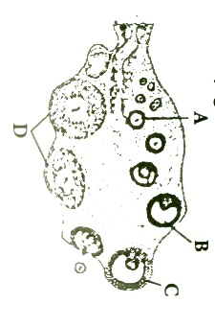

(a) Name the hormone that’s helps in growth of A $→$ B $→$ C.

(b) Name the hormone secreted by A and B

(c) State the role of hormone produced by D.

1. Refer to given figure below and answer the following questions: [ 4 ]

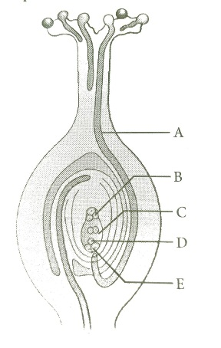

(a) What phenomenon is represented in above figure?

(b) What is the path of entry of pollen tube?

(c) Label the parts marked as A to E.

(d) What will happens after entering of pollen into one of the synergids?

1. Expand and explain the following : IVF , ZIFT , ICSI , MTP [ 4 ]
2. Reproductive Child Health Care (RCH) programmes are currently in operation. One of the major talks of these programmes is to create awareness amongst people about the wide range of reproduction related aspects as this is important and essential for building a reproductively healthy society. [ 5 ]

(a) “Providing sex education in schools in one of the way to meet this goal.” Give four points in support of your opinion regarding this statement.

(b) List 2 indicators that indicates a reproductively healthy society.

Or

(a) Mention the events that induce the completion of meiotic division of the secondary oocyte.

(b) Trace the journey of the ovum from the ovary, its fertilization and further development until the implantation of the embryo.

1. Study the graph given below related with menstrual cycle of human female. [ 5 ]

(a) Identify ovarian hormones X and Y mentioned in the graph and specify their source.

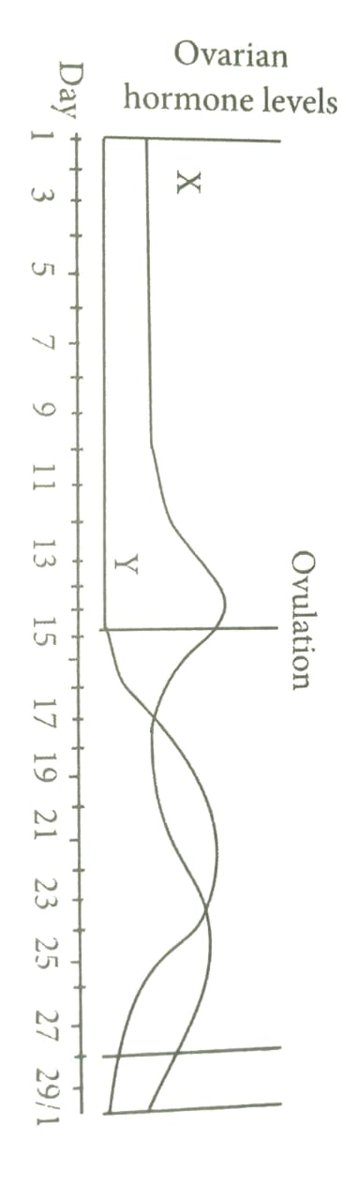

(b) Correlate and described the uterine events that take place according to the ovarian hormone levels X and Y mentioned in graph on : (i) 6-15 days (ii) 16 – 25 days (iii) 26-28 days (when ovum is not fertilized)